CLI Students Records Manager by Anjum
For MIT CS7001 Assignment Bachelor's of Electrical and Electronic Engineering
Features
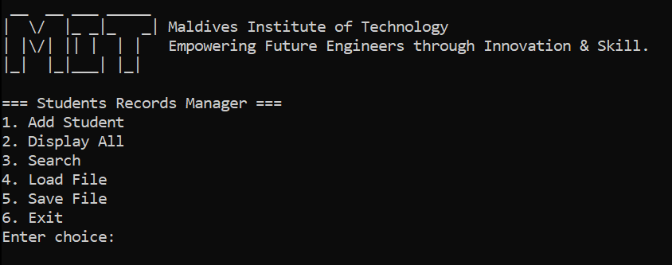
Allow adding student records with ID, name, and GPA
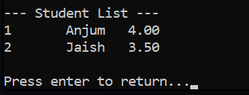
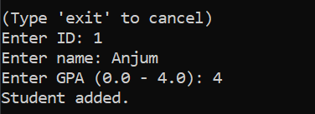
Display all student records
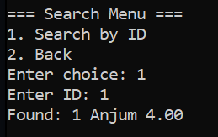
Search for a student by ID
Save and load records to a text file
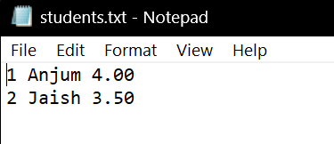
Input validation for all scenarios
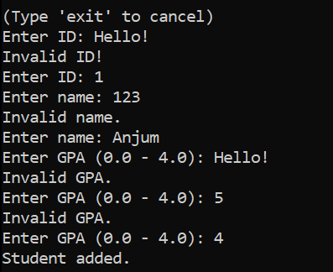
Dependencies
- Visual Studio Code (for compilation)

